**Using Google Analytics to Power SeattleSpots:**

**A Data-Driven Travel Website**

**Member Names:**

* Mustafa Bhavanagarwala
* Ming-Yeh Chiang
* Jake Chan
* Pravalli Budida
* Zehao Chi
* Site Mission Statement

The website is dedicated to showcasing the best travel attractions in Seattle and Washington state, offering visitors a comprehensive guide to must-visit locations, hidden gems, and cultural landmarks.

* Site Content Strategy  
    
  The CMS site will be used as a comprehensive guide to Seattle and Washington, giving engaging and useful content for visitors and locals. The platform will have well-structured content on popular attractions and places. To enhance user experience, unique content and curated travel recommendations are integrated. A good focus on SEO optimization and social media connectivity will make the content reach a wider audience, making the platform a great resource for exploring Seattle and its surroundings (Moz, n.d.).

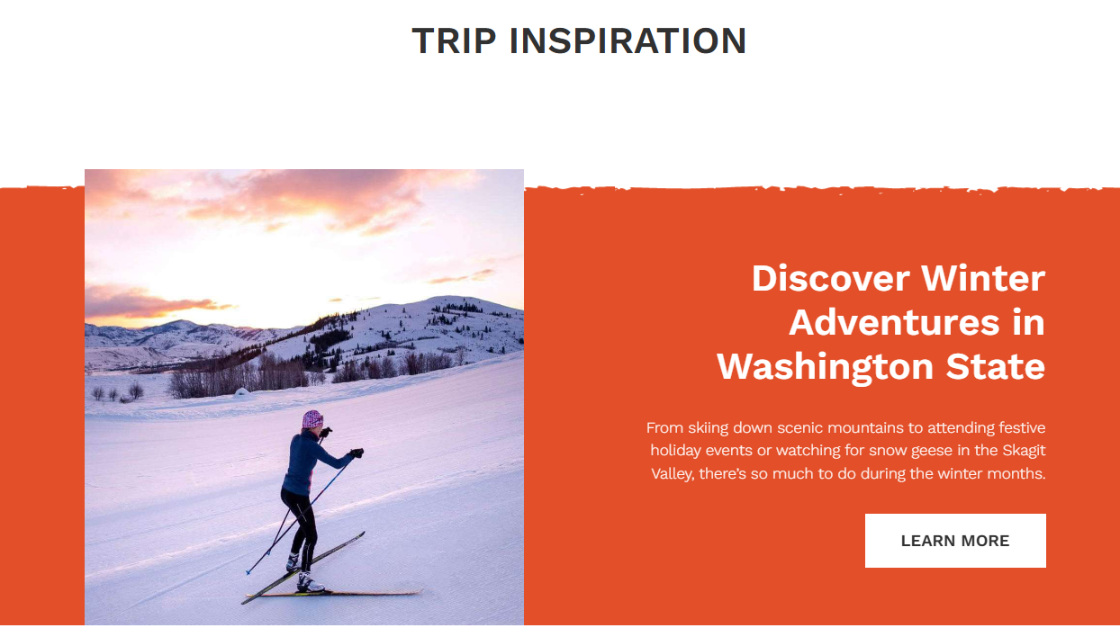

For reference, websites like Visit Seattle and State of Washington Tourism are analyzed. Visit Seattle is great for nice visuals, interesting articles, and immersive city guides. Washington Tourism effectively categorizes its content, offering detailed travel itineraries and insightful blogs that simplify trip planning. By combining these successful elements with a unique approach, the CMS will provide an engaging and practical experience for users looking to explore Seattle and Washington.(HubSpot, n.d.)

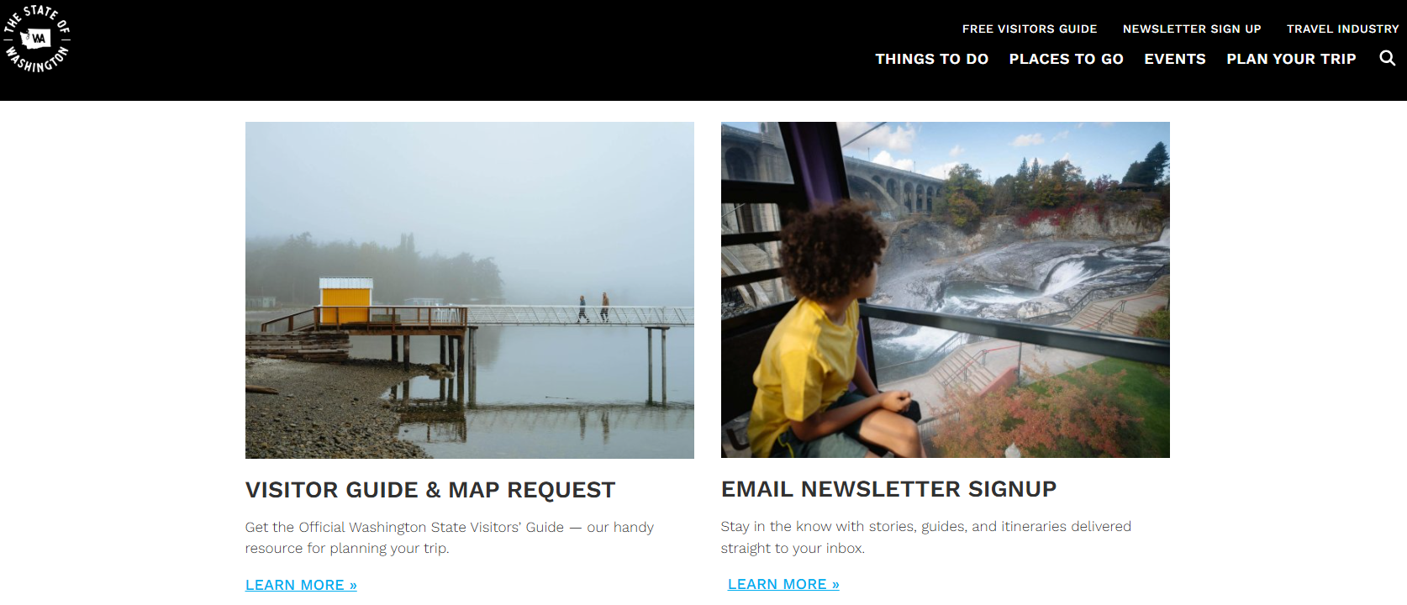

* Site Design Strategy

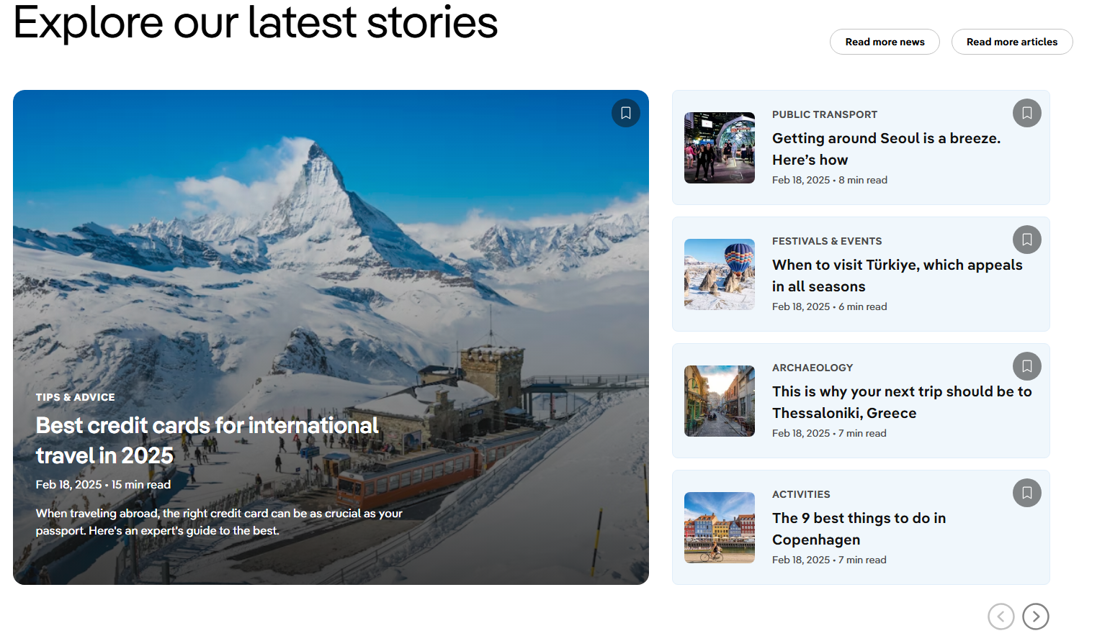

The website will follow a clean, modern aesthetic with intuitive navigation, ensuring users can easily explore different sections. A balance of high-quality images, engaging typography, and an easy-to-read layout will be maintained to enhance the browsing experience.

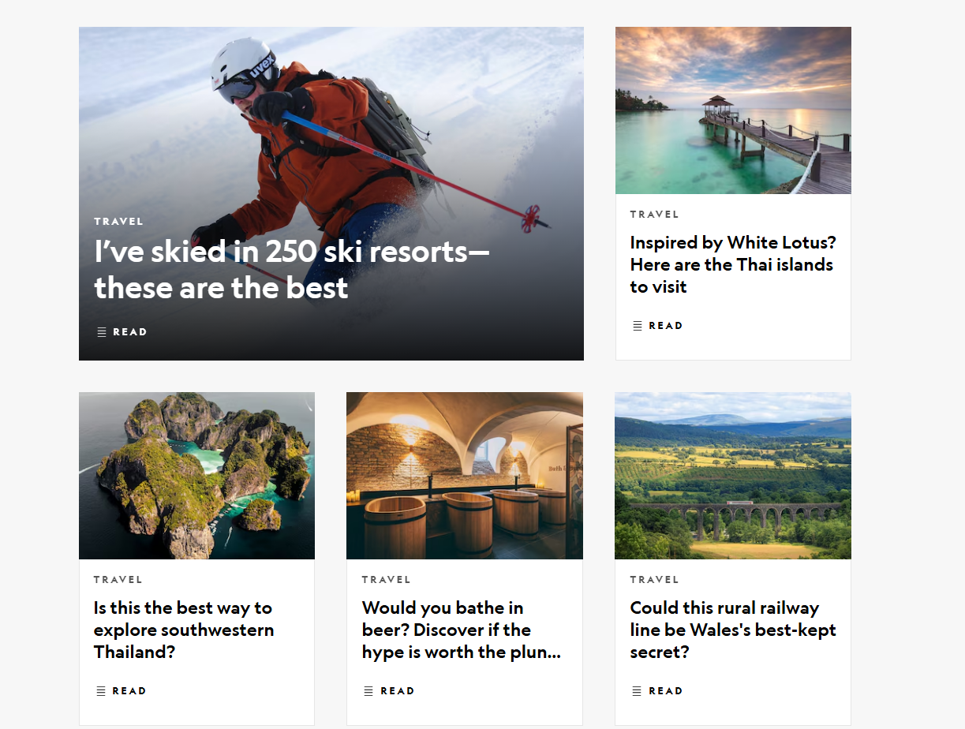

For inspiration, sites like **National Geographic Travel (https://www.nationalgeographic.com/travel/)** and **Lonely Planet (**[**https://www.lonelyplanet.com/**](https://www.lonelyplanet.com/)**)** are studied , both of which utilize strong visuals and an organized layout. The site will incorporate a **consistent color scheme**, **mobile-friendly design**, and **interactive elements**, such as hover effects and smooth transitions, to create an engaging experience.

References:

* HubSpot. (n.d.). Interactive content examples to boost engagement. Retrieved February 19, 2025, from https://blog.hubspot.com/marketing/interactive-content-examples
* Moz. (n.d.). SEO for travel websites: Strategies for boosting visibility. Retrieved February 19, 2025, from https://moz.com/blog/seo-travel
* State of Washington Tourism. (n.d.). Explore Washington. Retrieved February 19, 2025, from https://stateofwatourism.com/
* Visit Seattle. (n.d.). Official Seattle travel and tourism guide. Retrieved February 19, 2025, from https://visitseattle.org/